Wabash Tailgate!

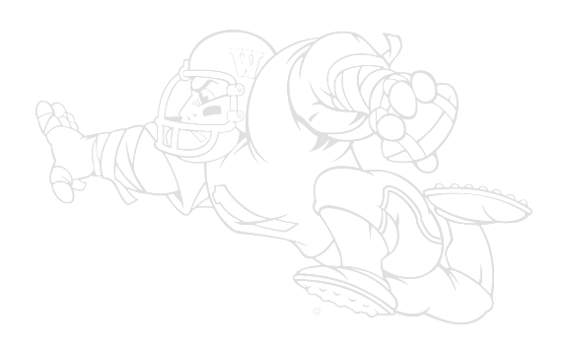
You are invited!
Join other Wabash College fans for a pre-game tailgate ‘Bash!

Wabash College
vs.
Wittenberg University

Date: October 14, 2006
Game time: 1:00 PM
Tailgate starts at 11:00 AM

Location: Across the street from the Wittenberg Admissions building. ( www.wittenberg.edu)

No host and no cost: Just bring something to eat and drink and join other Wabash fans as we get ready to cheer the Little Giants on to victory.

If you have questions, please contact Heather at bazzanih@wabash.edu or call 765-361-6360.
Wabash Tailgate
